Project Design Phase-II
Technology Stack (Architecture & Stack)

Date | 2 November 2025
Team ID | NM2025TMID00454
Project Name | Calculating Family Expenses using Service Now
Maximum Marks | 4 Marks

Technical Architecture:
The deliverable includes an architectural diagram showing the data flow and components of the Family Expense Calculation System developed using ServiceNow.
The architecture defines how users interact with the system through the ServiceNow interface, where data is processed, stored, and visualized.
Example: Calculating Family Expenses using ServiceNow
Guidelines:
Include all the processes (As an application logic / Technology Block)
Provide infrastructural demarcation (Local / Cloud) Indicate external interfaces (third party API’s etc.) Indicate Data Storage components / services
Indicate interface to machine learning models (if applicable)
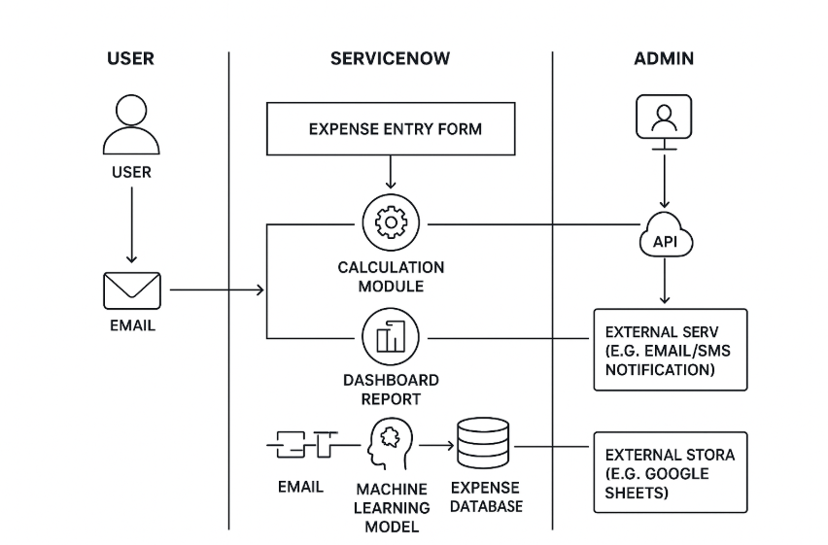

Table-1 : Components & Technologies:

S.No | Component | Description | Technology
1. | User Interface | Family members interact via ServiceNow web dashboard to input and view expenses. | ServiceNow Web UI
2. | Application Logic-1 | Handles expense entry and validation for category, date, and amount. | ServiceNow Flow Designer, Client Script
3. | Application Logic-2 | Calculates total and categorized expenses automatically. | GlideRecord in Server Script
4. | Application Logic-3 | Generates and displays reports and dashboards. | ServiceNow Performance Analytics
5. | Database |  | ServiceNow Custom Expense Table
  Stores expense details, user profiles, and budget information
6. | Cloud Database | Managed by ServiceNow’s secure cloud infrastructure. | ServiceNow Cloud Database
7. | File Storage |  | ServiceNow Attachments, System Logs
  Stores exported reports (PDF/Excel) and system logs.
8. | External API-1 | Optional integration with Google Sheets for external reporting. | REST API Integration
9. | External API-2 |  | Notification API, Twilio (optional)
  Optional integration with email or SMS alerts for
  budget notifications.
10. | Machine Learning Model | (Future Enhancement) Predict spending trends and provide saving suggestions. | AI Builder / Predictive Intelligence (optional)
11. | Infrastructure (Server / Cloud) | Hosted on ServiceNow SaaS Cloud. | ServiceNow Cloud (SaaS)

Table-2: Application Characteristics:

S.No | Characteristics | Description | Technology
1. | Open-Source Frameworks | Not applicable (ServiceNow is proprietary) | -
2. | Security Implementations | Role-based access control for users and admins. | ACLs, Scoped Applications
3. | Scalable Architecture | SaaS-based and horizontally scalable through ServiceNow Cloud. | ServiceNow Cloud Architecture
4. | Availability | Highly available ServiceNow platform ensures 99.99% uptime. | Load-balanced ServiceNow Instances
5. | Performance | Optimized through background scripts, indexed tables, and efficient queries. | GlideRecord, Asynchronous Flows
6. | Usability | Simple, intuitive dashboard for expense tracking and visualization. | ServiceNow UI Builder
7. | Reliability | Ensures accurate and consistent expense calculations. | ServiceNow Flow Designer

